Final Project Milestone Four
Cole Herman
DAT 220
SNHU

Correlations

 | zip | Restaurant | RES_VISITS | Webstore_Spend | WEB_VISITS | THIRD_SPEND | THIRD_VISITS | Age | Income
zip | 1.0000 | -0.0602 | -0.0906 | -0.1043 | -0.0928 | -0.0053 | 0.0465 | -0.0522 | 0.0085
Restaurant | -0.0602 | 1.0000 | 0.5955 | 0.4534 | 0.2078 | -0.0427 | -0.0379 | -0.0033 | -0.0159
RES_VISITS | -0.0906 | 0.5955 | 1.0000 | 0.2943 | 0.1839 | -0.0801 | -0.0846 | 0.0045 | -0.0307
Webstore_Spend | -0.1043 | 0.4534 | 0.2943 | 1.0000 | 0.6119 | -0.0059 | -0.0034 | -0.0368 | -0.0299
WEB_VISITS | -0.0928 | 0.2078 | 0.1839 | 0.6119 | 1.0000 | -0.0409 | -0.0103 | -0.0037 | 0.0301
THIRD_SPEND | -0.0053 | -0.0427 | -0.0801 | -0.0059 | -0.0409 | 1.0000 | 0.7422 | -0.0827 | -0.0601
THIRD_VISITS | 0.0465 | -0.0379 | -0.0846 | -0.0034 | -0.0103 | 0.7422 | 1.0000 | -0.0768 | -0.0636
Age | -0.0522 | -0.0033 | 0.0045 | -0.0368 | -0.0037 | -0.0827 | -0.0768 | 1.0000 | 0.1093
Income | 0.0085 | -0.0159 | -0.0307 | -0.0299 | 0.0301 | -0.0601 | -0.0636 | 0.1093 | 1.0000
First, I took the continuous variables into a multivariate analysis model. With this I was able to create a correlation table to see where the most valuable information was hidden. This analysis shows us that the strongest relationships exist between “restaurant spend” and “restaurant visits.” This is an assumed value however so we can move on to the next strongest values, “restaurant spend” and “webstore spend.” The next strongest after that would be “webstore spend” and “web visits”, and finally, “third party spend” and “third party visits. This allowed for a cleaner scatterplot matrix to be created that includes only the variables we wanted to look at.
Scatterplot

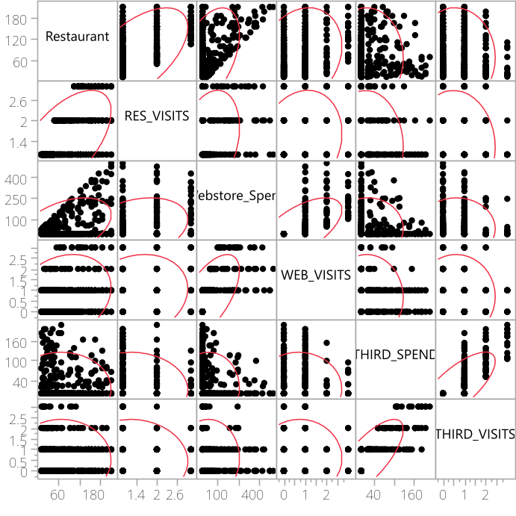
The scatterplot matrix confirms the relationships shown in our correlation’s analysis. The same variables – “restaurant spend, restaurant visits, web spend, web visits, third visits, and third spend” – when used in a principal component analysis we get the graphs below.
Summary Plots
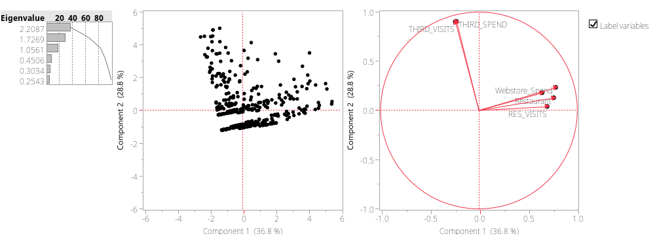
This shows that the two principal variables account for 65.5% of the variance. We can also see that while all variables positively correlate to our second component, third visits and third spend negatively correlate to component one.
Next, a cluster analysis was created with the same set of variables. The dendrogram below shows 20 natural clusters and offers a good visualization of them, but it does not provide detailed information on the contents of the clusters. For more information, we must look at the Cluster Means table.

Dendrogram

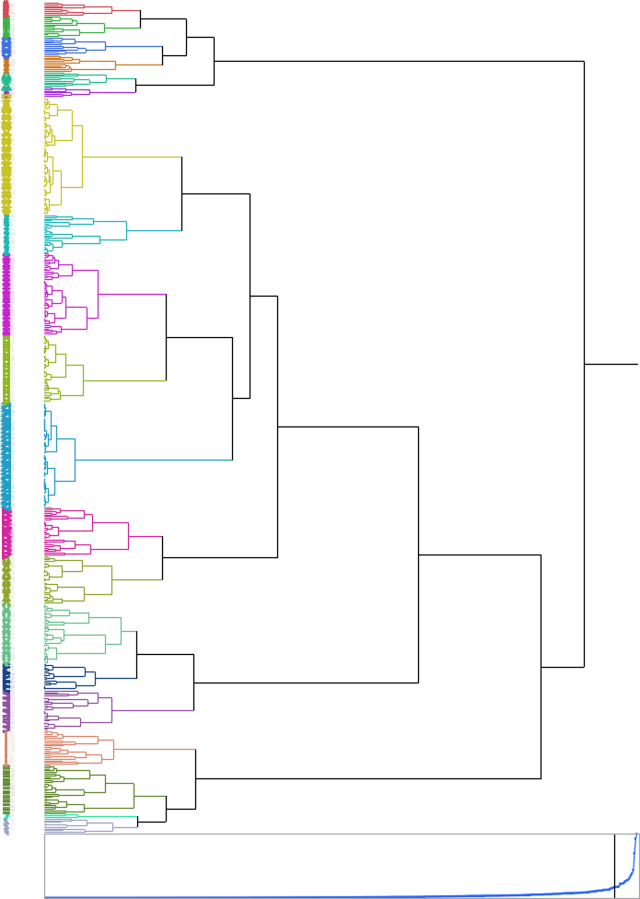

Cluster Means
Cluster | Count | Restaurant | RES_VISITS | Webstore_Spend | WEB_VISITS | THIRD_SPEND | THIRD_VISITS
1 | 8 | 160.00 | 1.63 | 243.00 | 2.88 | 40.63 | 1.25
2 | 13 | 92.46 | 1.54 | 162.08 | 3.00 | -7.1e-15 | 0.38
3 | 11 | 148.91 | 3.00 | 183.73 | 1.91 | 2.55 | 0.36
4 | 10 | 143.30 | 1.50 | 206.20 | 1.20 | 8.30 | 0.50
5 | 9 | 173.67 | 2.56 | 373.78 | 2.11 | 29.44 | 0.78
6 | 6 | 189.17 | 1.50 | 426.17 | 1.33 | -3.6e-15 | 0.00
7 | 71 | 31.42 | 1.00 | 15.24 | 1.00 | 2.84e-14 | 2.22e-16
8 | 23 | 53.87 | 1.35 | 93.35 | 1.83 | -7.1e-15 | 0.43
9 | 49 | 38.39 | 1.00 | 19.02 | 1.00 | 13.08 | 1.00
10 | 41 | 30.78 | 1.00 | -2.1e-14 | 2.22e-16 | 9.12 | 1.00
11 | 63 | 35.41 | 1.00 | -7.1e-14 | 8.88e-16 | 2.84e-14 | 1.11e-16
12 | 29 | 124.69 | 1.00 | 9.52 | 0.34 | 23.31 | 1.07
13 | 29 | 127.66 | 1.00 | 3.79 | 0.45 | -7.1e-15 | -4.4e-16
14 | 36 | 98.78 | 2.00 | 2.61 | 0.42 | -7.1e-15 | -5.6e-16
15 | 16 | 112.56 | 2.00 | 0.00 | 0.50 | 1.19 | 1.00
16 | 24 | 153.88 | 3.00 | 5.08 | 0.38 | 6.42 | 0.33
17 | 21 | 52.86 | 1.10 | 6.81 | 0.48 | 163.29 | 2.62
18 | 29 | 41.03 | 1.00 | 15.07 | 0.52 | 104.69 | 1.59
19 | 3 | 116.67 | 1.33 | 229.33 | 1.00 | 115.00 | 2.33
20 | 9 | 108.78 | 2.11 | 16.78 | 0.67 | 82.00 | 1.44

This table shows that more customers fall into cluster 7 than any other cluster. This cluster consists of customers who spent an average of $31 at a restaurant, and $15 on the webstore, while also spending very little with third parties. It is also important to note that these customers usually have visited the webstore and a restaurant at least once. Cluster 19is the cluster with the the fewest customers. This cluster includes only 3 customers that spent a considerable amount at each of the three sources.
I created linear regression models using continuous variables from our data set. While the scatter plots for a few of the different models shows relationships between different variables, the probabilities greater than F and T suggested only one is statistically significant: “restaurant spend” and “webstore spend.”

Bivariate Fit of Restaurant by Webstore_Spend
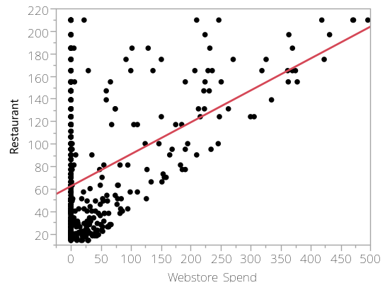

The scatter plot with regression line shows that customers who spend more at a Bubba Gump restaurant are likely to spend on the webstore and that customers who did not spend as much at the restaurant.

Linear Fit
Restaurant = 62.700655 + 0.2837215*Webstore_Spend
Summary of Fit
RSquare | 0.20557
RSquare Adj | 0.203975
Root Mean Square Error | 49.06054
Mean of Response | 74.184
Observations (or Sum Wgts) | 500

Analysis of Variance
Source | DF | Sum of Squares | Mean Square | F Ratio
Model | 1 | 310168.5 | 310168 | 128.8644
Error | 498 | 1198654.6 | 2407 | Prob > F
C. Total | 499 | 1508823.1 |  | <.0001*

Parameter Estimates
Term |  | Estimate | Std Error | t Ratio | Prob>|t|
Intercept |  | 62.700655 | 2.416025 | 25.95 | <.0001*
Webstore_Spend |  | 0.2837215 | 0.024993 | 11.35 | <.0001*

The estimates for this linear regression model create a sound model that reinforces the hypothesis that “restaurant spend” affects “webstore spend.” The low probability greater than F in this model describes that if we substituted the mean value for that variable in the data, it would not create a better model than what we have generated.

Logistic Fit of WEB_PURCH_YN by WEB_VISITS
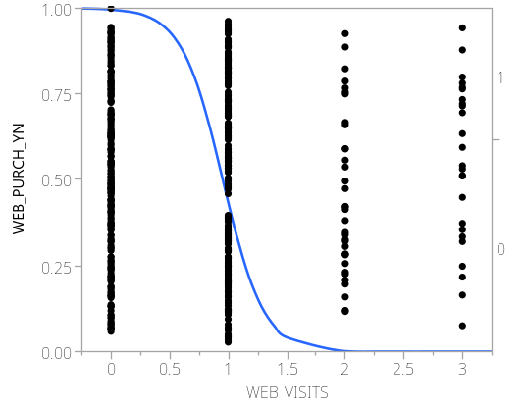
The logistic regression model can be used to make predictions. This model uses a binary value for web purchase (yes or no) and then web visits is a 1, 2, or 3. While the points on the scatter plot may appear to confirm that customers who make multiple visits to the webstore will be less likely to make a purchase than those who only visit the webstore once. The line shows predicted probability that a customer will make a purchase regarding how many visits they have mad; it clearly declines as it approaches 3 visits.

Whole Model Test
Model | -LogLikelihood | DF | ChiSquare | Prob>ChiSq
Difference | 170.28874 | 1 | 340.5775 | <.0001*
Full | 162.22863
Reduced | 332.51737

RSquare (U) | 0.5121
AICc | 328.481
BIC | 336.886
Observations (or Sum Wgts) | 500

Measure | Training | Definition
Entropy Rsquare | 0.5121 | 1-Loglike(model)/Loglike(0)
Generalized Rsquare | 0.6716 | (1-(L(0)/L(model))^(2/n))/(1-L(0)^(2/n))
Mean -Log p | 0.3245 | ∑ -Log(ρ[j])/n
RMSE | 0.3373 | √ ∑(y[j]-ρ[j])²/n
Mean Abs Dev | 0.2274 | ∑ |y[j]-ρ[j]|/n
Misclassification Rate | 0.1980 | ∑ (ρ[j]≠ρMax)/n
N | 500 | n

Parameter Estimates
Term |  | Estimate | Std Error | ChiSquare | Prob>ChiSq
Intercept[0] |  | 5.44197476 | 1.002145 | 29.49 | <.0001*
WEB_VISITS |  | -5.72761 | 1.0079514 | 32.29 | <.0001*

The probability greater than ChiSq, shows that the effect that the number of “web visits” has on whether a customer makes a purchase is significant enough to make predictions customer behavior.
The relationship between “restaurant spend” and “webstore spend,” and the relationship between the number of webstore visits shows an upward trend in webstore purchase. These relationships present themselves during each stage of this analysis and across multiple models we created. While variable pairs that at first show no relationship in earlier stages of analysis were continuously analyzed to develop no evidence of existing relationships.
However, there are limitations due to lacking or completely missing data. For this reason, this report does not offer any solutions to increase Bubba Gump Shrimp Company’s revenue, but it does provide an excellent direction for follow-up analyses.
I would suggest that the relationship between the increased number of webstore visits and webstore purchases were made to be analyzed further regarding the type of products purchased there. Since the analysis shows that customers who visited the webstore more often were less likely to make a purchase we cannot determine why. This information could be paired with inventory analysis and products. Additional surveys could be sent to customers who made several visits without buying anything to determine why this was the case however it is important to note that these customers may not. One hypothesis formed during the creation of my analysis is that customers are returning to the webstore seeking a specific item that was not available or priced too steeply. Comparing our web sales against stock information or pricing points could prove invaluable.
The scatterplots showed clear data in an easily analyzed format. Looking at my generated scatter plot alone allowed us to quickly eliminate certain outlier variables that did not support our found relationships in any significant way. The different data that we created along side the scatter plot with our linear and logistic regression models further help identify which models actual furthered our analysis.
The dendrogram produced by the cluster analysis offered a visualization of how the clusters were organized in relation to each other, but it did not really offer any insight into the differences between each cluster or exactly how many customers fell into each different cluster. The cluster means table offered data to match to each visual cluster in the dendrogram and outlined exactly how each cluster was organized.
The principal components analysis suggested that there were relationships within the variables selected that were significant and accounted for over half the variance within the analysis. The visualization, unfortunately, doesn’t offer any specific details into which relationships those are.

